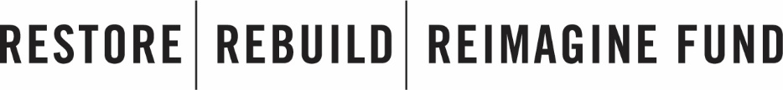

The purpose of the Restore-Rebuild-Reimagine (RRR) Fund is to help Minneapolis and St. Paul small businesses that were damaged in the civil unrest following the murder of George Floyd.

The following types of work are currently being offered through the RRR Fund to repair and improve the fronts of buildings/businesses:

* **Exterior Improvements** 
  + Paint
  + Outdoor murals
  + Siding improvements
  + Signage
  + Pressure washing
* **Security Improvements**
  + Window & door improvements (window film, storefront, doors, and hardware)
  + Surveillance cameras (exterior only)
  + Exterior lighting improvements (sconce lighting, fog lights, wall packs, etc.)

**ELIGIBILITY**

To be eligible to receive assistance through the RRR Fund, your business/property must have an address that is located on either Lake Street in Minneapolis, West Broadway Ave in Minneapolis, or University Ave in St. Paul.

**CONTACT**

Questions? Contact [**rrrfund.info@gmail.com**](mailto:rrrfund.info@gmail.com)

*Visit* [*restorerebuildreimaginefund.org*](https://restorerebuildreimaginefund.org/) *to learn more about the Restore-Rebuild-Reimagine Fund.*



To request assistance, please provide the following information. A member of our team will contact you to discuss your business/property.

Completed forms can be submitted to [**rrrfund.info@gmail.com**](mailto:rrrfund.info@gmail.com) or by mail to **1527 E. Lake Street, Minneapolis, MN 55407 (Attn: Mortenson)**

You may also complete this form online at: [**http://bit.ly/rrrfund**](http://bit.ly/rrrfund)

|  |  |
| --- | --- |
| 1. **Name of Business:** |  |
| 1. **Business Address:**   (include city and zip code) |  |
| 1. **Business Owner First and Last Name:** |  |
| 1. **Business Owner Email:** |  |
| 1. **Business Owner Phone:** |  |
| 1. **Do you also own the building where your business is located?**   Yes No If yes, skip to question #10 | |
| 1. **Property Owner First and Last Name:** |  |
| 1. **Property Owner Email:** |  |
| 1. **Property Owner Phone:** |  |
| 1. **What is the best way to contact you?** (email, phone, or in-person) |  |
| 1. **When is the best time to contact you?**   (example: Tuesdays before 9 AM) |  |
| 1. **Please tell us your preferred language:** | |
| 1. **Was your business or property damaged during the civil unrest of Summer 2020?**   Yes No | |
| 1. **Briefly describe the damage:** |  |